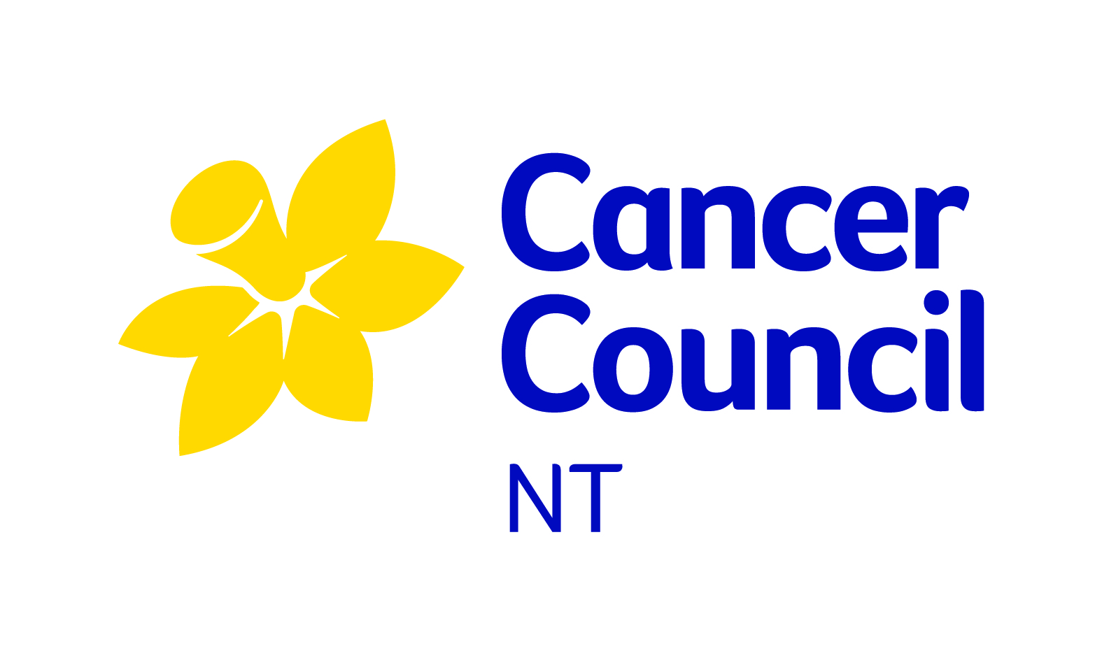


SAMPLE POLICY

Schools are welcome to copy this SunSmart sun protection policy directly and use it as their own or incorporate all of the main points into their own sun protection policy.

<Name of school>'s sun protection policy

Rationale
A balance of ultraviolet radiation (UV) exposure is important for health. Too much exposure to ultraviolet (UV) radiation from the sun causes sunburn, skin damage and increases the risk of skin cancer. Sun exposure in the first 15 years of life contributes significantly to the lifetime risk of developing skin cancer. Australia has the highest rate of skin cancer in the world. Skin cancers account for 80% of all new cancers diagnosed in Australia each year. Approximately, two in three Australians will be diagnosed with skin cancer before the age of 70.

This policy is followed all year round in the Northern Territory as the UV radiation levels are always high, very high or extreme particularly during peak UV periods (10am – 3pm). The policy incorporates OSHC and Vacation Care programs if held on school grounds.

Staff will act as role models in line with the SunSmart program role modelling requirements and OHS standards. Staff are required to adopt all protective measures put in place by their employer as part of employee OHS responsibilities.

Objectives
This SunSmart policy provides guidelines to:
- ensure all students and staff are protected from over-exposure to UV radiation;
- encourage the entire school community to use a combination of sun protection measures all year round when the UV levels are 3 or above;
- ensure all children and staff have a balance of UV exposure to maintain healthy vitamin D levels;
- ensure a safe outdoor environment that provides shade for students and staff;
- ensure students are encouraged and supported to develop independent sun protection skills to help them be responsible for their own sun protection;
- support duty of care requirements; and
- support appropriate OHS strategies to minimise UV risk and associated harms for staff and visitors.

Procedures
- To assist with the implementation of this policy, staff and students are encouraged to access the daily local sun protection times via the SunSmart widget on the school’s website, the free SunSmart app, or www.bom.gov.au
- The sun protection measures listed are used for all outdoor activities during the daily local sun protection times.

The sun protection times are a forecast from the Bureau of Meteorology for the time of day UV levels are forecast to reach 3 or higher. At these levels, sun protection is recommended for all skin types. In Northern Territory, UV levels regularly reach 3 or higher all year round.

Sun Protection strategies:
- All students and staff use a combination of sun protection measures during the daily sun protection times (whenever UV levels are 3 or above). Particular care is taken between 10 am and 3 pm when UV levels reach their peak.
- The SunSmart policy is considered when planning all outdoor events e.g. assemblies, camps, excursions and sporting events. Where possible, we aim to have outdoor activities or events earlier in the morning or later in the afternoon, and use indoor venues.

1. Shade
- The school committee makes sure there is a sufficient number of shelters and trees providing shade in the school grounds particularly in areas where students congregate eg. Lunch area, canteen, outdoor lesson areas and popular play areas.
- In consultation with the school council, shade provision is considered in plans for future buildings and grounds.
- The availability of shade is considered when planning excursions and outdoor activities.
- Students are actively encouraged to use available areas of shade when outside. Students who do not have appropriate hats or outdoor clothing are asked to stay in an area protected from the sun.

2. Clothing

Sun protective clothing is included in our school uniform/dress code and sports uniform. School clothing is made of close weave fabric and includes shirts with collars and longer sleeves, longer style dresses and shorts. Rash vests or t-shirts will also be worn when swimming outdoors.
(Please note: Singlet tops and cap sleeves are not considered sun protective and are therefore not acceptable).

3. Hats
- Students are also required to wear hats that protect their face, neck and ears, i.e. bucket, broad-brimmed or legionnaire hats whenever they are outside.
(Please note: Baseball caps are not considered sun protective and are therefore not acceptable.)
- Students who do not have an appropriate sun protective hat will be asked to stay in shaded areas only.

4. Sunglasses [SUGGESTED]
- Students and staff are encouraged to wear close fitting, wrap around sunglasses that meet the Australian Standard 1067 (Sunglasses: Category 2, 3 or 4) and cover as much of the eye area as possible.

5. Sunscreen
- SPF 50 or SPF 50+, broad-spectrum, water-resistant sunscreen is available for staff and student's use. Time sunscreen is applied at least 20 minutes before going outdoors and reapplied every two hours as required. Time will be allocated for sunscreen application prior to outdoor activities.

Role Modelling
- Staff act as role models by:
- wearing sun protective hats (broad brimmed, bucket or legionnaire hats), clothing and sunglasses outside (please note that baseball caps do not offer enough protection and are therefore not acceptable)
- applying SPF 50 or SPF 50+, broad-spectrum, water-resistant sunscreen
- seeking shade whenever possible
- Families and visitors are encouraged to use a combination of sun protection measures (sun protective clothing and hats, sunglasses and sunscreen) when participating in and attending outdoor school activities.

Curriculum
- Sun protection, vitamin D and skin cancer awareness programs are incorporated into appropriate areas of the school curriculum.
- Students are encouraged to be involved in initiatives to promote and model sun protection measures to the whole school community.
- SunSmart behaviour is regularly reinforced and promoted to the whole school community through newsletters, school homepage, parent meetings, staff meetings, school assemblies, student and teacher activities and on student enrolment.

Review
- The school council and staff monitor and review the effectiveness of the sun protection policy every three years and revise the policy when required. Next policy review: . . . . . . . . . . . . . . .

Please attach your school’s sun protection policy to your completed application/agreement form and return it to us by email or post to:

Email : Prevention@cancernt.org.au
Address : Casi House,
2/25 Vanderlin Drive
Wanguri NT 0910
PO Box 42719 Casuarina NT 0811

For further information about your sun protection policy or the SunSmart Schools Program, please contact
Cancer Council NT
SunSmart Infoline : 08 8944 1805 Fax : 08 8927 4990
Email : Prevention@cancernt.org.au

